Dr. Anshu Arora
Principles of Marketing
MTKG 3175
NIKE
“JUST DO IT”
Case Study Analysis
Nevada Harris

Table of Contents

Executive Summary & Situation Analysis………………..3
Customer & Company Analysis………………………………...4
Mission, Vision, Objective……………………………………….5
Competitive Market Analysis………………………………….. 7
SWOT Analysis ………………………………………………………8
Marketing Strategy ………………………………………………11
BCG Matrix ………………………………….. 12
Porter’s Competitive Strategy………………………………13
Marketing Plan Objectives……………………………………...15
Differentiation…………………………………………..15
Marketing Mix and STPs………………………………………..16
Implementation…………………………………………………..19
Control…………………………………………………………….19

Executive Summary
Nike Inc. was founded in 1962 by Bill Bowerman and Phil Knight as a partnership under the name, Blue Ribbon Sports. Our modest goal then was to distribute low-cost, high-quality Japanese athletic shoes to American consumers in an attempt to break Germany's domination of the domestic industry. Today in 2011, Nike Inc. not only manufactures and distributes athletic shoes at every marketable price point to a global market, but over 40% of our sales come from athletic apparel, sports equipment, and subsidiary ventures. Nike maintains traditional and non-traditional distribution channels in more than 100 countries targeting its primary market regions: United States, Europe, Asia Pacific, and the Americas (not including the United States). We utilize over 20,000 retailers, Nike factory stores, Nike stores, NikeTowns, Cole Haan stores, and internet-based Web sites to sell our sports and leisure products. We dominate sales in the athletic footwear industry with a 33% global market share. Nike Inc. has been able to attain this premier position through "quality production, innovative products, and aggressive marketing." As a result, for the fiscal year end 1999, Nike's 20,700 employees generated almost $8.8 billion in revenue.

Situational Analysis
This includes an assessment of the company, customers, competitors and external market environment. This information is then summarized with an S.W.O.T analysis.
Company Analysis
Nike is the largest seller of athletic footwear and athletic apparel in the world. The Nike swoosh is one of the most recognizable business logos on earth. It is more than a symbol of excellence in brand marketing. Nike has revolutionized the way companies approach the sports market. Nike gets involved in anything related to sports, including technological breakthroughs, retailing, sports management and sports promotion. Nike operates in a market that is consumer-oriented. This means that the demand for the Nike's goods heavily depends on the popularity of the various fitness activities. The company adjusts continuously their product mix in order to meet demands. It manages its business carefully, leading in aggressive marketing styles and innovative products.

Customer Analysis
In comparison with the VALS survey, Nike is targeting those innovators along with experiencers. Innovators are successful, sophisticated, take-charge people with high self-esteem. Because they have such abundant resources, they exhibit all three primary motivations in varying degrees. They are change leaders and are the most receptive to new ideas and technologies. Experiencers are motivated by self-expression. Young, enthusiastic, and impulsive consumers, Experiencers quickly become enthusiastic about new possibilities but are equally quick to cool. They seek variety and excitement, savoring the new, the offbeat, and the risky. Their energy finds an outlet in exercise, sports, outdoor recreation, and social activities.

Mission
Nike’s mission is “to bring inspiration and innovation to every athlete”. In the words of Co-owner Bill Bowerman, "If you have a body, you are an athlete."

Vision
“At Nike, our vision is to remain the leader in our industry. We will continue to produce the quality products that we have provided in the past. Most importantly, we will continue to meet the ever-changing needs of our customers, through product innovation.”
Company Objectives
Nike was founded on a handshake. Implicit in that act was the determination that we would build our business based on trust, teamwork, honesty and mutual respect. As they have grown from a two-man partnership to a global business, their task has been to maintain this same ethic across their operations. They’ve put in place corporate governance policies and practices as well to help.
But their greatest challenge that they will face in 2011 will be to maintain the operational and financial initiatives that they have worked so hard to implement in 1998 and 1999. They must maintain their inventory levels low enough that will allow them to adapt to quickly changing market trends. Financially, they must remain conservative in cost structure. Cuts to operating expenses of almost $200 million this past year demonstrated that they are in a position to be nimble in light of our industry-dominating size. With the gradual economic recovery in the Asia Pacific region, we can capitalize on customers who are financially stronger. Their past sponsorship of the 2000 Olympic Games in Sydney, Australia, and the 2002 World Cup in Japan and Korea was the start of many opportunities to bring sports events into the mainstream for regional and global markets and still is today with many sponsorships such as the 2011 Women’s World Cup along with the 2012 Olympic Games. With added exposure, they are challenged to respond to a market demand for fashionable athletic footwear and apparel. The Internet is a rapidly changing medium. As the first company in the industry to offer e-commerce capabilities, they must proceed with caution and stealth in order to select an enduring strategy that will complement their existing distribution channels.
Competitive Marketing Analysis
Nike evolved as a result of the use of continuous innovative strategies using a cushioning and stability system in the firm’s products. Nike’s approach to marketing changed in its 2002 “Secret Tournament” campaign, the first truly integrated approach. Reebok approach to the industry has very similar strategies, but with a focus toward fitness. The products from Nike offer continuous new and innovative methods from research and development directed for the company’s consumers. Reebok produces a product called “Easytone” that is targeted to women in fitness using a technology invented by a former NASA engineer. Nike operates in over six geographies; North America, Western Europe, Eastern/Central Europe, Greater China, Japan, and emerging markets. Reebok has expanded to a Global Corporate Citizenship that helps under privilege youth around the world. Nike promotes the brand of footwear, apparel, and equipment product engines through creative methods of communication targeting customers. Reebok provides unique and authenticity to give diversity to customers. The Nike’s retail price and quality are relatively high, and the unit price is low as it creates large quantity sales. Reebok offers a lower retail price and quality.
External Market Environment – PEST Analysis
Political Environment
Nike contributes to federal, state, and local level political campaigns. Nike supports politics through political action committees made up of employees of the corporation. PAC supports both political parties favoring those most sensitive to the support of Nike’s business interest and goals.

Economic Environment
Nike has over 36,000 employees globally. Nike collects billions of dollars in revenue. More than $2.5 billion comes from the affiliate brands.
Social and Cultural Environment
Nike’s support of the 2002 “Secret Tournament” created expansion to the consumers showing a diverse effort at the World Cup. Nike’s (RED) is a united way of fighting against HIV/AIDS in Africa, partnering with the Global Fund and the world football community.
Technology Environment
Nike IHM, Inc. is a facility Nike owns that produces AIR-SOLE cushioning components. Nike also sells these special parts used in Nike footwear products to other manufacturers. Nike has won the Gigaton Award for Energy-Saving Programs Aimed at Reducing Global Greenhouse Gas Emissions in 2011.
SWOT ANALYSIS
Strengths:
- Nike is the world’s no. 1 shoemaker. It designs and sells shoes for a variety of sports including baseball, golf, cheerleading, volleyball, tennis and football.
- Nike uses a “Make to Stock” customer order which provides a fast service to customers from available stock.
- Nike operates Nike Town shoe and sportswear stores, Nike factory outlets and Nike Women shops. Nike sells its products throughout US and in more than 180 countries.
- Nike is strong at research and development, as is evidenced by its evolving and innovative product range. They then manufacture wherever they can produce high quality product at the lowest possible price.
- Nike is a global brand. It is the number one sports brand in the World. Its famous ‘Swoosh’ is instantly recognizable, and Phil Knight (Founder and CEO) even has it tattooed on his ankle.
Weaknesses:
- The income of the business is still heavily dependent upon its share of the footwear market. This may leave it vulnerable if for any reason its market share erodes.
- The retail sector is very price sensitive. However, most of its income is derived from selling into retailers. Retailers tend to offer a very similar experience to the consumer. So margins tend to get squeezed as retailers try to pass some of the low price competition pressure onto Nike.
Opportunities:
- Product development offers Nike many opportunities. The brand is fiercely defended by its owners whom truly believe that Nike is not a fashion brand however consumers that wear Nike product do not always buy it to participate in sport. In youth culture especially, Nike is a fashion brand. This creates its own opportunities.
- There is also the opportunity to develop products such as sport wear, sunglasses and jewelry.
- The business could also be developed internationally, building upon its strong global brand recognition. There are also global marketing events that can be utilized to support the brand such as the World Cup (soccer) and The Olympics.
Threats:
- Nike is exposed to the international nature of trade. It buys and sells in different currencies and so costs and margins are not stable over long periods of time. Such an exposure could mean that Nike may be manufacturing and/or selling at a loss. This is an issue that faces all global brands.
- The market for sports shoes and garments is very competitive. Competitors are developing alternative brands to take away Nike’s market share.
Marketing Strategy
Nike’s marketing strategy rested entirely upon a brand image which is favorable and has evolved into a great multinational enterprise over time. The favorable brand image has been kept afloat due to the strong association with the Nike’s logo which is quite distinctive and the slogan “Just Do It” which has been used in advertisement for quite some time. The company has been known to invest heavily in advertisements and brand promotion.
Most of the consumers of Nike’s products are mainly sportsmen. This is so because of the utility that comes with the products. An athlete is more likely to go a sports shoe designed and marketed by Nike more than a person who detests sporting and exercises. Nike targets these consumers by agreements between Nike and athletic teams, college’s athletic teams1 etc for product sponsorship and eventual promotion to the members of these teams. In this way, Nike is able to reach a wide number of consumers and consumers who are more likely to buy. Even though others are likely to buy the products, Nike pays specific emphatic targeting to the athlete more than any group of individuals even though it also targets the youth who have embraced the hip hop culture.
Nike lays a number of strategies to target their immediate consumers; athletes and other sportsmen. The targeting strategies include among others the sponsorship of products by professional athletic teams, celebrity athletes and college athletic teams. This strategy is specifically successful because of its ability to reach a large number of athletes. If the athletic team manager prescribes a specific type of track shoes made by Nike, the trainees have no option other than to buy them. The teams can as well buy the track shoes in bulky and supply them to the team members.
The second strategy that Nike applies is the designing of product destination. It does this by associating success with the product. For example, when a celebrity athlete sponsors a specific brand of athletic shoes, the brand will be associated with success. This psychological effect is reinforced with advertisements that affirm this position. Nike also targets the consumers who are likely to develop product intimacy; those who care more about the utility and quality of the product than the price. In this way, the pricing is not affected too much in a bid to accommodate a large number of consumers.

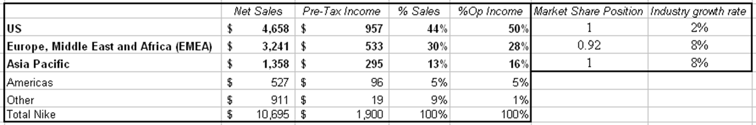
BCG Matrix

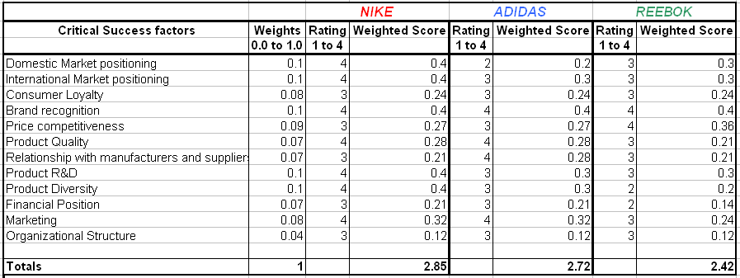
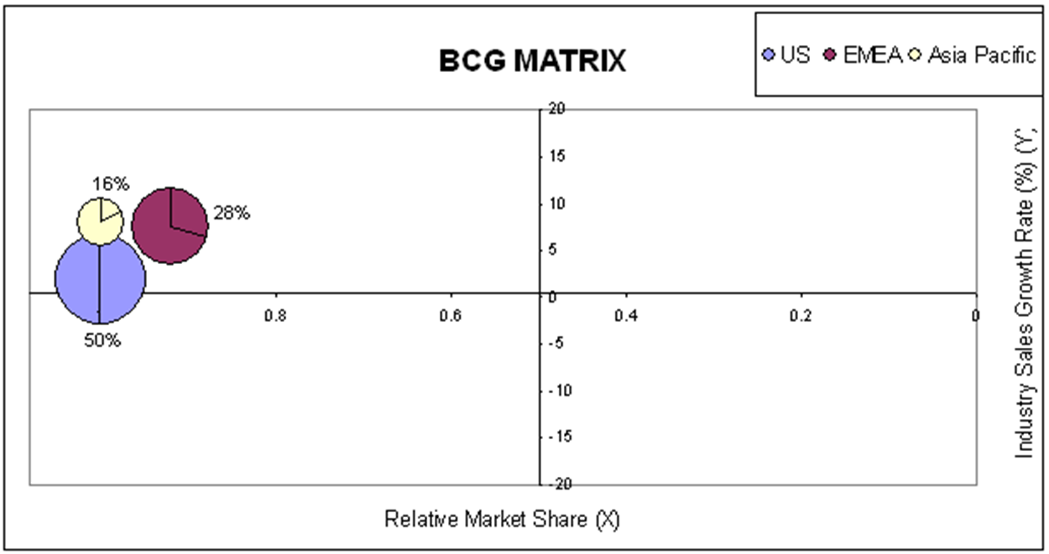
In this diagram it is saying that Nike is in the cash cow section of the BCG matrix.
Porter’s Competitive Strategy
Rivalry
Rivalry in the apparel and footwear industry is very proactive. Many new sports conglomerates are attracted to this market due to high and promising profits. Nevertheless, NIKE faces only few competitors that come close to its size and product differentiation. The company’s major competitors include Adidas, Reebok, and Fila USA, the latter of which is a privately held company. During the 1990’s, NIKE controlled nearly half of the market. Once competitors started rapidly entering this market, NIKE’s market share fell to 32.5% in 2002. However, NIKE is still considered to be the leader in the footwear industry, since it is ranked number one (1) in US and International sales. Adidas-Solomon, on the other hand, is the fourth (4) largest US seller of athletic footwear and the second (2) largest globally, while Reebok currently comes second (2) in US sales in this area. Another fast growing company Sketchers has acquired a significant market share in the past few years. Sketchers’ market share rose to 5 5% in 2002, but compared to the top athletic footwear manufacturers such as NIKE, Sketchers is still a very small player in this colossal industry.
Barriers to Entry
Product Technology
NIKE has always striven to provide a competitive edge to foster the best possible performance in their athletes. This is the reason NIKE continues to lead innovation in footwear, apparel, and equipment. The ability to test and examine footwear products serves as one of the major barriers for any footwear company that considers entering the market. NIKE is already highly advanced in the Research and Development area. Specifically, NIKE operates its own Sport Research Lab, where it carefully examines each of its new products.
Proprietary Knowledge
NIKE has invested and achieved the most amongst any other sports company in developing cushioning systems that reduce shock, distribute pressure, and provide comfort for athlete’s feet. NIKE is credited with being the first to design footwear that encapsulates air to cushion foot-strike. The company’s scientists have also engineered a new model called “Zoom Air” for NIKE’s running shoe-line. Zoom Air shoes are very light and they are designed to bring the athlete’s foot closer to the ground to allow greater maneuverability.
Brand Identity
NIKE enjoys the popularity of its brand name, which is recognized all around the world. Its name carries a trademark, and thus makes it illegal for other companies to infringe upon the NIKE name. Besides the brand name, the company also has a trademark for the ‘Swoosh Design’ logo that identifies NIKE Inc. In fact, NIKE considers its name and the ‘Swoosh’ symbol to be the most valuable assets; therefore, the company registered these trademarks in over 100 countries.
Patents
One of the exclusive licenses that distinguishes NIKE from the rest of its competitors is the patented “Air” technology that the company uses to sell footwear. “The process utilizes pressurized gas encapsulated in polyurethane." Although some NIKE AIR patents have expired, NIKE still holds a number of subsequent NIKE AIR patents, and patents that cover specific features in various athletic and leisure shoes that will not expire for several years. In addition, the company places a significant emphasis on its Research and Development, Production and Marketing, and Design departments to maintain its competitive edge.
Marketing Plan Objectives
Nike’s marketing objective is to employ a range of marketing communication tactics that can cater to the organization’s target market, who have different nationalities, genders, cultures, and ages. To enable this, Nike introduces its latest products through a marketing communication group that can strengthen the “positioning of, and key messages about, the Nike brand,” through different forms of visual aids and point-of-purchase advertising. In connection to this, Nike continuously aims to apply marketing tactics that are appropriate with the people who reside in these continents or nations. For example, aside from traditional advertising in the form of television, billboards, and the like, Nike also makes use of contemporary marketing instruments such as the internet, wherein people in almost any part of the world could access various sites to customize Nike shoes and products.
Product Differentiation
Product differentiation is healthy in the footwear industry and allows the company to increase its profits through the sale of different products. Another advantage of manufacturing a number of product lines is the reduction of risk in that if one product fails there are numerous other products to compensate for this loss. Companies in the apparel and footwear industry that concentrate on manufacturing a single product are at a great disadvantage since their revenues depend exclusively on the sales of only one type of product, therefore, increasing the potential default risk. NIKE designs most of its footwear for athletic use; however, in order to diversify its products, a large percentage of their products come from sales of footwear, apparel, and accessories for casual and leisure purposes.

Marketing Mix and STPs
Nike is one of the pioneers in marketing and has one of the strongest marketing mix. Depending mainly on pull strategy, it has established its hold in face of major competitors like Adidas and Reebok. Read on for its product marketing mix.
1. Product:
Nike offers a wide range of shoe, apparel and equipment products, all of which are currently its top-selling product categories. Nike started selling sports apparel, athletic bags and accessory items in 1979. Their brand Cole Haan carries a line of dress and casual footwear and accessories for men, women and children.
They also market head gear under the brand name Sports Specialties, through NikeTeam manufactures and distributes ice skates, skate blades, in-roller skates, protective gear, hockey sticks and hockey jerseys and accessories.

2. Price:
Nike’s pricing is designed to be competitive to the other fashion Shoe retailer. The pricing is based on the basis of premium segment as target customers. Nike as a brand commands high premiums. Nike’s pricing strategy makes use of vertical integration in pricing wherein they own participants at differing channel levels or take part in more than one channel level operations. This can control costs and influence product pricing.
3. Place:
Nike shoes are carried by multi-brand stores and the exclusive Nike stores across the globe. Nike sells its product to about 20,000 retail accounts in the U.S. and in almost 200 countries around the world. In the international markets, Nike sells its products through independent distributors, licensees and subsidiaries. The company has production facilities in Asia and customer service and other operational units worldwide
4. Promotion:
Promotion is largely dependent on finding accessible store locations. It also avails of targeted advertising in the newspaper and creating strategic alliances. Nike has a number of famous athletes that serve as brand ambassadors such as the Brazilian Soccer Team (especially Ronaldo, Renaldo, and Roberto Carlos), Lebron James and Jermane O’Neal for basketball, Lance Armstrong for cycling, and Tiger Woods for Golf.
Nike also sponsors events such as Hoop It Up and The Golden West Invitational. Nike’s brand images, the Nike name and the trademark swoosh; make it one of the most recognizable brands in the world. Nike’s brand power is one reason for its high revenues. Nike’s quality products, loyal customer base and its great marketing techniques all contribute to make the shoe empire a huge success.
Segmentation
Those who use to engage in the designated athletic activity. Also those who use the shoes primarily for casual wear and seldom engage in the athletic activity. Nike's segmenting market typically target's athletes, both women and male generally from the ages 15 to 35.
Targeting
Nike's targeting market is active people who enjoy high quality sporting goods, especially footwear. To do so Nike focuses on creating premium consumer experiences on product innovation, brand leadership and elevated retail presence. Nike is targeting further geographic expansion and farther marketing penetration in all regions. Though disciplined operating management, the company still continues to target long range mid teen earnings per share growth.

Positioning
Their goal is to spread the understanding of sustainability throughout the company and demonstrate its value to the business and its customers. In 21st century, you must successfully integrate corporate responsibility into the heart of the business. The Nike name and associated trademarks have appeared everywhere from players' shirts, pants, and hats to stadium banners and walls. Aggressive advertising campaigns, celebrity endorsements, and quality products enhance the brand. Their position against the competition is very strong thanks to new products that they produce.
Implementation
Nike’s chose to rebuild the company to leverage the strengths and to pursue the firm’s potential. The revenue is down by one percent but more profitable than ever with revenue at $19 billion in May 2010. The gross margin made a record at 46.3 percent.

Control
The trend started with Nike’s approach toward campaigning to support the World Cup generated tens of millions of consumers tracked through Nike’s online community. Nike continues to monitor the company’s efforts to lead the company’s competitive advantages through established performance standards.

